**Polygons A**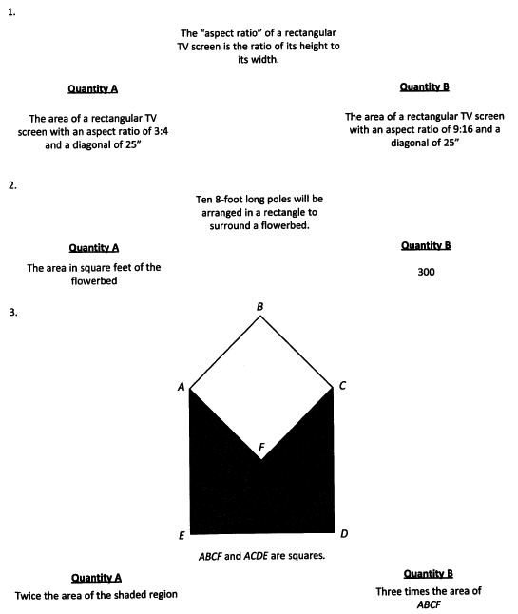

1. A
2. D
3. C

**Polygons B** 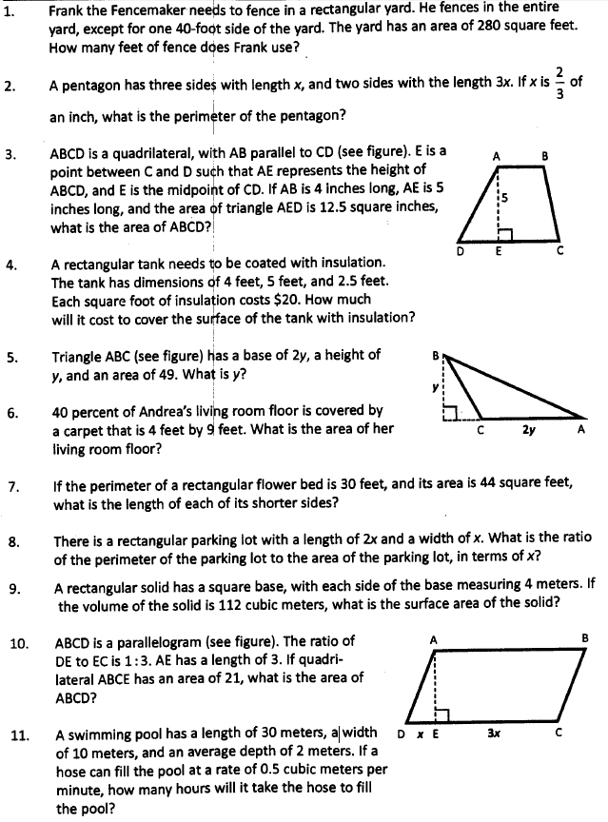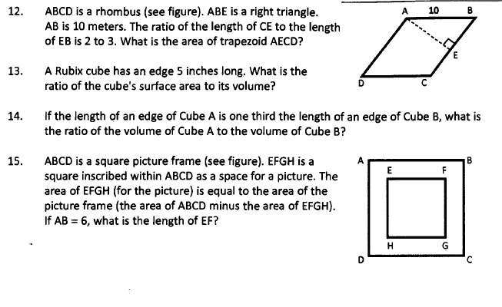

1. 54 feet
2. 6 inches
3. 35
4. 1700
5. 7
6. 90
7. 4
8. 144
9. 24
10. 20
11. 56
12. 1 to 27
13. 3

**Triangles A**

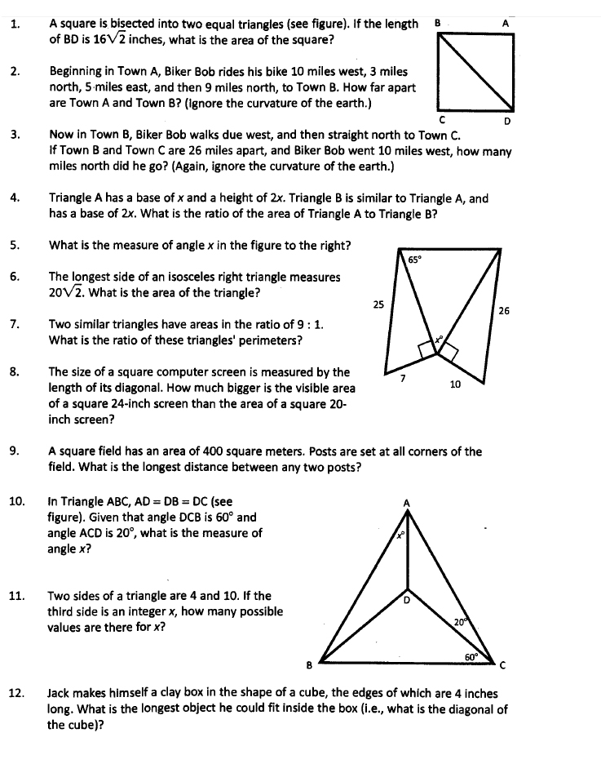

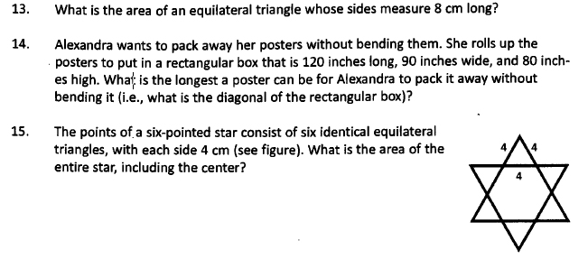

1. 256
2. 13
3. 24
4. 1 to 4
5. 50
6. 200
7. 3 to 1
8. 88
9. 20
10. 10
11. 7
12. 4
13. 16
14. 170
15. 48

**Triangles B**

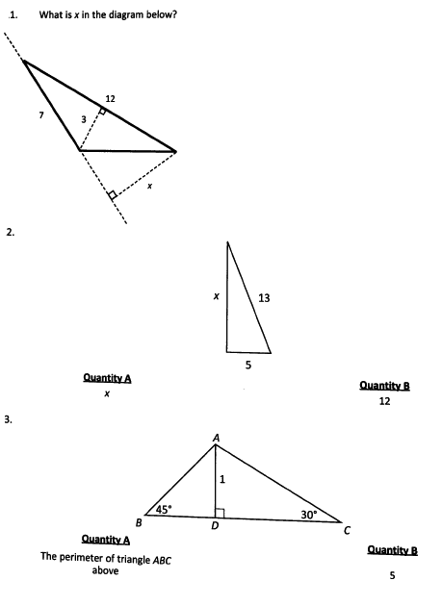

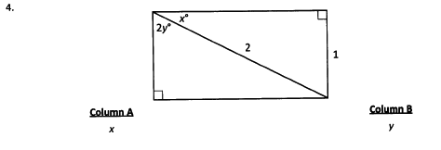

1. 5.142
2. D
3. A
4. D

**Miscellaneous Questions**

1. Two sides of a triangle have length 6 and 8. Which of the following are possible areas of the triangle? Indicate all possible values
2. 2
3. 12
4. 24
5. If a right triangle has area 28 and hypotenuse 12, what is its perimeter? 28 [hint: Use formula (a+b)²=a² + b²+ 2ab]

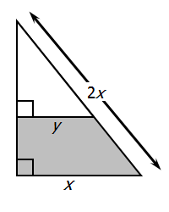

1. For the figure above, in terms of x and y, what is the area of the shaded region?

Note: Figure not drawn to scale

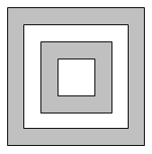

1. In the figure above, if the areas of the 4 squares are 50, 32, 18 and 12, what is the ratio of the small shaded portion to the area of the large shaded portion? 1:3

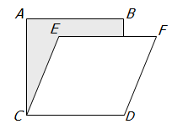

1. For the figure above, if ABCD is a square with area 625, and CEFD is a rhombus with area 500, then the area of the shaded region is 275

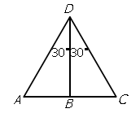

1. Please refer to the figure above

Column A: AB

Column B: BC

CBD

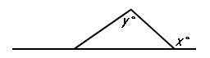

1. Column A: x

Column B: y

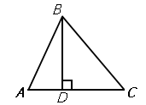

1. Column A: BD/AB

Column B: BC/DC

1. If x>0, and two sides of a certain triangle have lengths 2x+1 and 3x+4 respectively, which of the following could be the length of the third side of the triangle? Indicate all possible lengths.
2. 4x+5
3. x+2
4. 6x+1
5. 5x+6
6. 2x+17
7. If the length and width of rectangle R are each increased by 1, the area of the new rectangle will be 72. If the length and width of rectangle R are each decreased by 1, the area of the new rectangle will be 35. What is the perimeter of rectangle R? 37

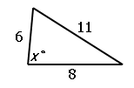

1. Column A: x

Column B: 90

